This is the assignment for graphic group.

I installed the Elive on my laptop and upgrade the operating system, after the installation I also upgrade the operating system. I also download a couple of applications.

I navigate through the various theme categories. I checked the following on each themes category: background, configuration, the icons.

I checked the wallpaper settings and navigate through them. I was download some personal wallpaper that I added to the default wallpaper.

I changed the desktop couple of times and I took the screenshot. On Sunday Bradon and I worked on the group assignments for couple of hours. I

I added the water tree art and dna nasa wallpapers to the operating system wallpaper.

Below are the screenshots of the desktops

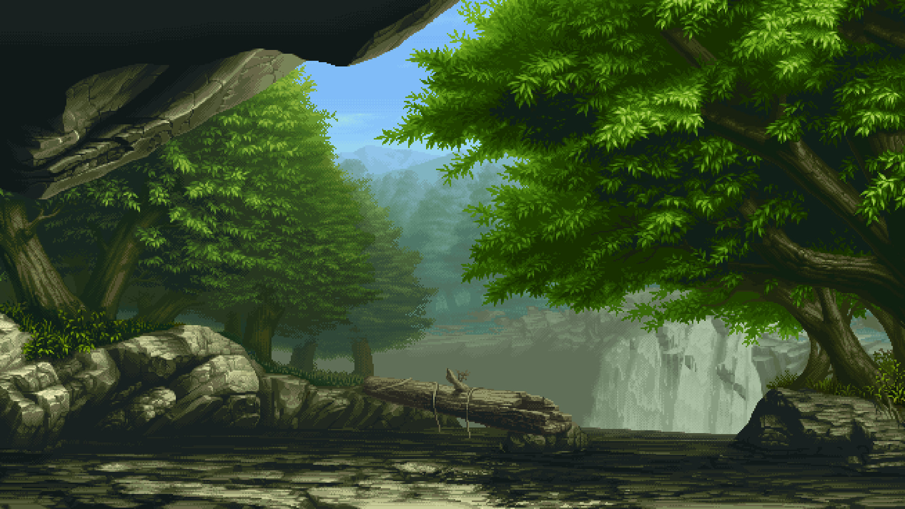**I added this Water tree art**

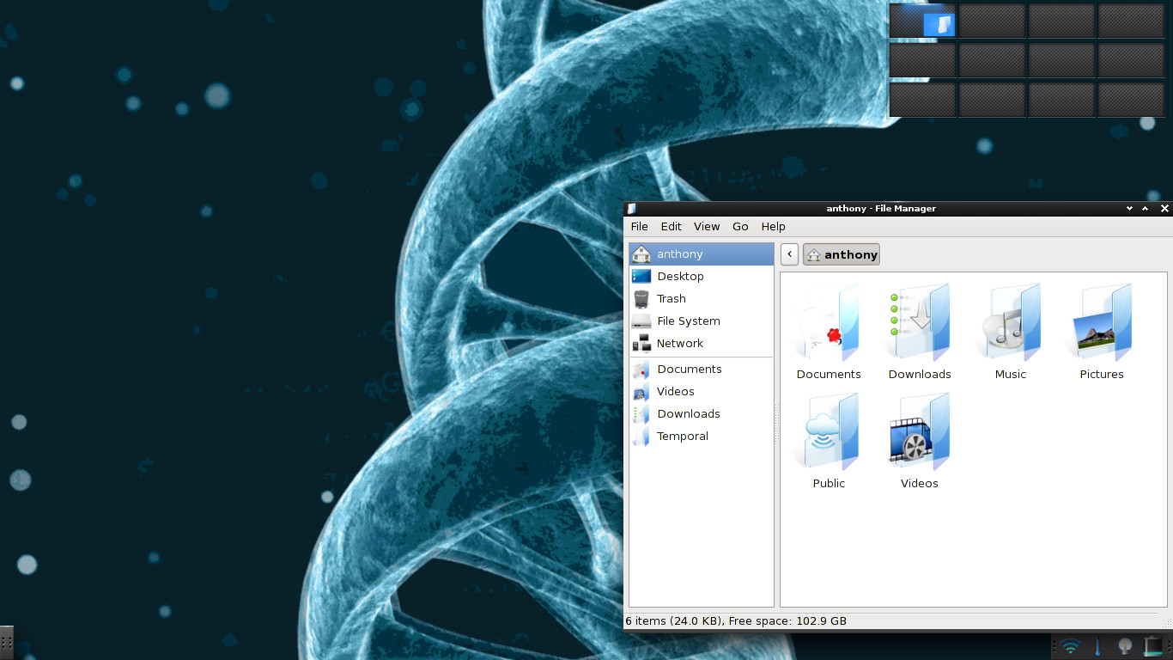dna nasa wall paper